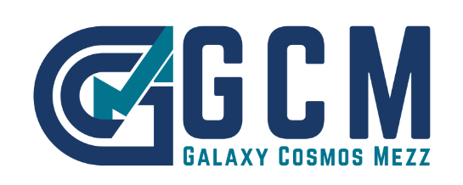

*Nicosia, November 3, 2022*

**Announcement**

**Notification of voting rights**

Galaxy Cosmos Mezz PLC (”the Company”) announces, in accordance with Article 14 of the Alternative Market Regulation, as in force, and following relevant notification from Mr. John Paulson dated November 1, 2022, that the latter holds indirectly as of October 31, 2022 (first day of trading of the Company shares on the EN.A. PLUS segment of the Alternative Market of Athens Stock Exchange), through “Paulson & Co. Inc.”, a company controlled by him, 4,874,904 common registered voting shares of a nominal value of €0.27 each, namely 5.66% of the total number of 86,194,164 common shares and voting rights of the Company.

“Paulson & Co. Inc.” is the investment manager of the funds that hold directly the shares in the Company and as manager it exercises the voting rights on behalf of the funds.